

**MAJOR PROJECT LAB**

**Component: Synopsis**

**Project Title: IGNIS**

Guided by: Dr Nismon R

Aleena MJ (1741104)

Meghna Sen (1741133)

**Personal Statement**

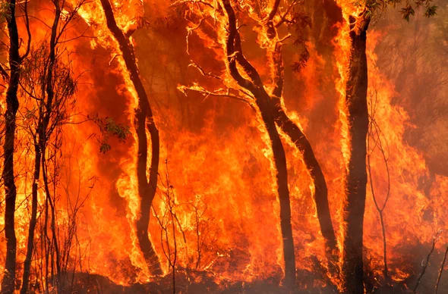

Forests are the protectors of earth’s ecological balance. Unfortunately, a forest fire is usually only observed when it has already spread over a large area, making its control and stoppage arduous and even impossible at times. In the past years not only has global warming increased, but also the occurrence of forest fires. We hope that with this project we are able to successfully monitor and detect forest fires, and put them out before any irreversible damage is done.

**Objective**



The proposed system ‘Ignis’ is developed to detect and monitor forest fires through IoT and free open source cloud like Thingspeak. In this project we propose to build a fire detection and alert system using Arduino UNO. The microcontroller is interfaced with a temperature sensor, a smoke sensor, ultrasonic sensor. In order to implement this project, we will be using GSM Modem which will provide the SMS alert to the administrator (in this case, an official) through the given number in the simulation program whenever the values of temperature and humidity sensor cross the threshold values.

**Background and Rationale**

A number of existing models were studied and their effectiveness was compared. Ahmed Imteaj studied the problems faced by factory workers in times when a fire breaks out. They proposed a system using Raspberry Pi 3 which is capable of detecting fire and providing information about area of fire. The Raspberry Pi controls multiple Arduino boards which are connected with several motors and cameras to capture the fire incident. In this, they discussed about the modern technology that can be used to reduce extremely unfortunate accidents caused by fire.

Sowah designed and implemented a fire detection system for vehicle using fuzzy logic. They have used sensors for detecting the fire. They used the air-conditioning system for extinguishing fire. The authors have focused on how to process the data collected by the sensors rather than how to detect or sense the fire. They used neural network for processing the collected data and make the network energy efficient. They used smoke color and spreading characteristics of smoke to detect possible fire outbreak. But processing the images is time consuming and needs sophisticated resources. In different cases, the fire should be detected as soon as possible because different materials take varied time to perish in a fire. They also used the GSM/GPS system for locating the exact location of the fire. In our proposed system, we are using more sensors than the aforementioned system and we process them centrally using Arduino.

Azka Ihsan Nurrahman, Kusprasapta Mutijarsa have proposed a prototype for a centralized management system for homes or offices which helps better in managing the safety features. In this, home management system is required. This system controls the room lights by turning on and off automatically, it keeps a record of use of electronic device status, turning on and off the ac regulator automatically, it displays the room temperature at home. If fire is detected in the house, it turn on sprinkler at home, it supervises at home via surveillance cameras,take photos and store them including recordings of surveillance at home, it detects the movements of people at home, and provide notification when someone enters the house.

**Specific Aims**

The aim of the project is to detect and monitor forest fires, as well as send alerts to the administrator regarding the level of the fire.

*Aim 1: Detection of Forest Fire*

The main aim of the project is to detect the fire before it gets out of hand. The sensors in the system will have certain default values stored. When the fire begins, it will be detected by the various sensors. As soon as the sensors return certain values, they will be checked for deviation from the threshold values. If there is a major deviation, an alert will be sent.

*Aim 2: Sending Fire Alert to Administrator*

The second aim is to pass the information obtained from the fire to the administrator. The system will measure the temperature, humidity and smoke at that instance of time and send an SMS alert to the administrator, stating what level the fire has reached.

*Aim 3: Sending Fire Data to Cloud*

When the fire is detected, the data will be sent to ThingSpeak, a free IOT cloud platform. Over there, the data for each fire will be stored. This dataset can later be used to analyze the causes of the fire and how to prevent them in the future.

*Aim 4: Analysis of Data*

The data collected from the forest fires can be used to predict forest fires and hence prevent them, with the help of graphs, charts and prediction algorithms.

**Project Approach**

Ignis proposes a system for tracking and alarming for the protection of trees against forest fires. In this project we will build fire detector using Arduino UNO which is interfaced with a temperature sensor, a smoke sensor . In order to implement this project, we will be using GSM which is used to provide the final SMS to the user through the given number in the simulation program, Temperature sensor which is used to denote the temperature High and Low, Smoke sensor which is used to denote the smoke ranges. Whenever a fire occurs, the system automatically senses and alerts the user by sending an alert to user’s mobile using GSM module.

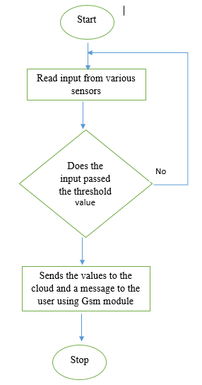

**Timeline**

|  |  |
| --- | --- |
| **PHASE** | **ESTIMATED DATES** |
| REQUIREMENT ANALYSIS | 18/11/2019-30/11/2019 |
| SYSTEM DESIGN | 2/12/2019-21/12/2019 |
| SYSTEM DEVELOPMENT | 22/12/2019-07/02/2020 |
| SYSTEM TESTING | 10/02/2020-22/02/2020 |
| DOCUMENTATION | 24/02/2020-08/03/2020 |

**Budget**

|  |  |
| --- | --- |
| **COMPONENT** | **ESTIMATED PRICE (IN RS.)** |
| Arduino Uno | 405 |
| Arduino WiFi Shield ESP826 | 425 |
| Temperature and Humidity Sensor DTH1L | 108 |
| Smoke Sensor MQ2 | 208 |
| Ultrasonic sensor | 75 |
| GSM Modem | 825 |
| Female to Male Jumper wires | 77 |
| Male to Female Jumper wires | 123 |
| Bread Board | 78 |
| **TOTAL** | **2324** |

**Literature Cited**

[1] Ahmed Imteaj,Tanveer Rahman, Muhammad Kamrul Hossain, Mohammed Shamsul Alam and Saad Ahmad Rahat. An IoT based Fire Alarming and Authentication System for Workhouse using Raspberry Pi 3 [https://www.researchgate.netpublication/316907062_An_IoT_based_fire_alarming_and_authentication_system_for_workhouse_using_Raspberry_Pi_3](https://www.researchgate.net/publication/316907062_An_IoT_based_fire_alarming_and_authentication_system_for_workhouse_using_Raspberry_Pi_3)

[2]Digvijay Singh, Neetika Sharma, Mehak Gupta, Shubham Sharma. Development of System for Early Fire Detection using Arduino UNO [http://ijesc.org/uploa](http://ijesc.org/upload/2a90e682fbf7d492be043a7bbb3a28d9.Development%20of%20System%20for%20Early%20Fire%20Detection%20using%20Arduino%20UNO.pdf)[/](https://www.researchgate.net/publication/316907062_An_IoT_based_fire_alarming_and_authentication_system_for_workhouse_using_Raspberry_Pi_3)[d/2a90e682fbf7d492be043a7bbb3a28d9.Development%20of%20System%20for%20Early%20Fire%20Detection%20using%20Arduino%20UNO.pdf](http://ijesc.org/upload/2a90e682fbf7d492be043a7bbb3a28d9.Development%20of%20System%20for%20Early%20Fire%20Detection%20using%20Arduino%20UNO.pdf)

[3]<https://circuitdigest.com/microcontroller-projects/arduino-flame-sensor-interfacing>

[4]R. Angeline, Adithya S, Abishek Narayanan. Fire Alarm System Using IOT

<https://www.ijitee.org/wp-content/uploads/papers/v8i6s3/F10200486S319.pdf>

[5]Dubey V., Kumar P., Chauhan N. (2019) Forest Fire Detection System Using IoT and Artificial Neural Network

<https://link.springer.com/chapter/10.1007/978-981-13-2324-9_33>

[6]Miriyala, Trinath & Karthik, Ragipati & Mahitha, J & Reddy, V. (2018). IoT based forest fire detection system

<https://www.researchgate.net/publication/324054113_IoT_based_forest_fire_detection_system/citation/download>